

American International University- Bangladesh

CSC 3222: Web Technologies

CO1.1 and CO2.1 Evaluation

Project Report

Fall/Spring/Summer 21-22

Project Title: Online Food Ordering System

Section: N/A

Group Number: N/A

|  |  |
| --- | --- |
| Student Name | Student Id |
|  |  |
|  |  |
|  |  |
|  |  |

Introduction:

*Nowadays, technology makes anything possible. We developed the online food ordering system called Hello Food!. The user can order food using this system from anywhere. And if they wish to place an order, they should come to the restaurant when the food is ready to pick it up.*

*.*

Background Study

*There are many online food ordering services available nowadays, including foodpanda(<https://www.foodpanda.com.bd/>), Pathaofood(*[*https://pathao.com/food/*](https://pathao.com/food/)*), Hungrynaki(*[*https://hungrynaki.com/*](https://hungrynaki.com/)*), and others. But, they also take orders and deliver food. By using our website, people may place orders for food, which can then be picked up or eaten in the restaurant once it is ready.*

Requirement Analysis:

1. User Category:

There are 2-types of Users here. They are:

* Admin
* User

1. Feature List:

In this project the “Admin” has the following features:

* Can login to the system
* Can create update delete view the categories
* Can create update delete view the products/foods
* Can create update delete view the user
* Can view and status change the order details
* Can view and change profile info

In this project the “User” has the following features:

* Can registration to the system
* Can login to the system
* Can view products/foods
* Can choose products/foods
* Can create an order
* Can view order details
* Can view and change profile info

Design:

ER Diagram:

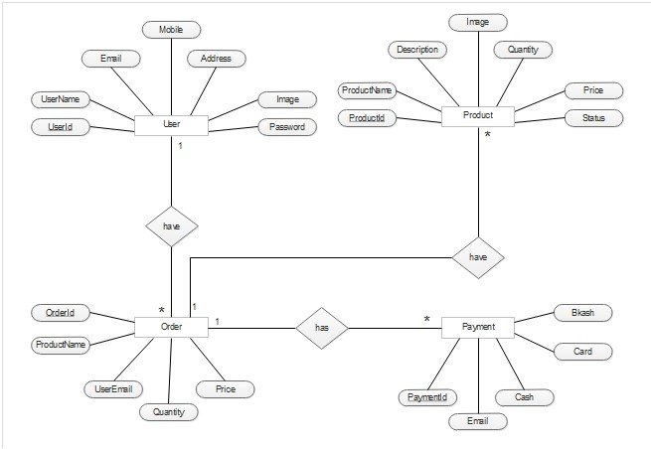

Database Design:

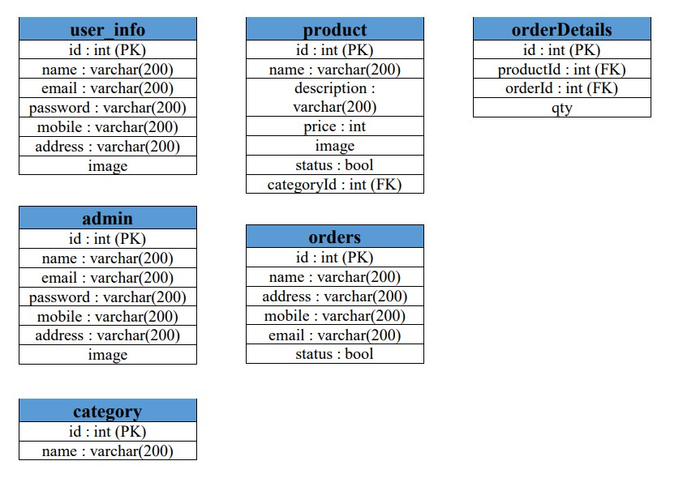

Tools Used:

To develop this project, we have used the following:

• Xampp

• VS Code

System Images against the Specification:

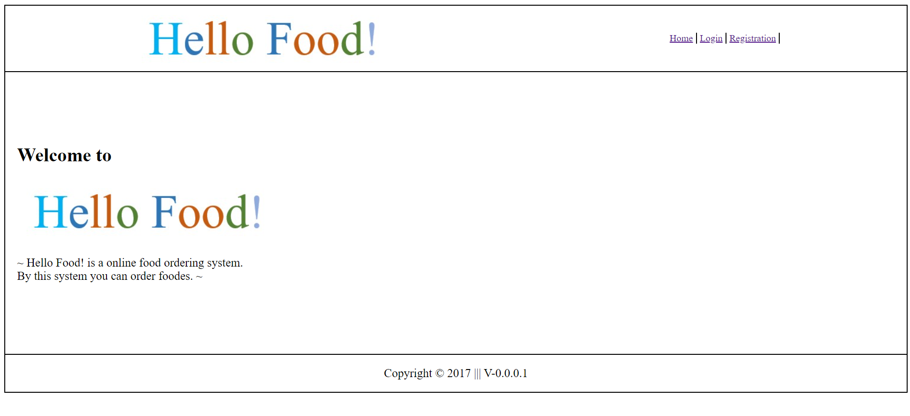

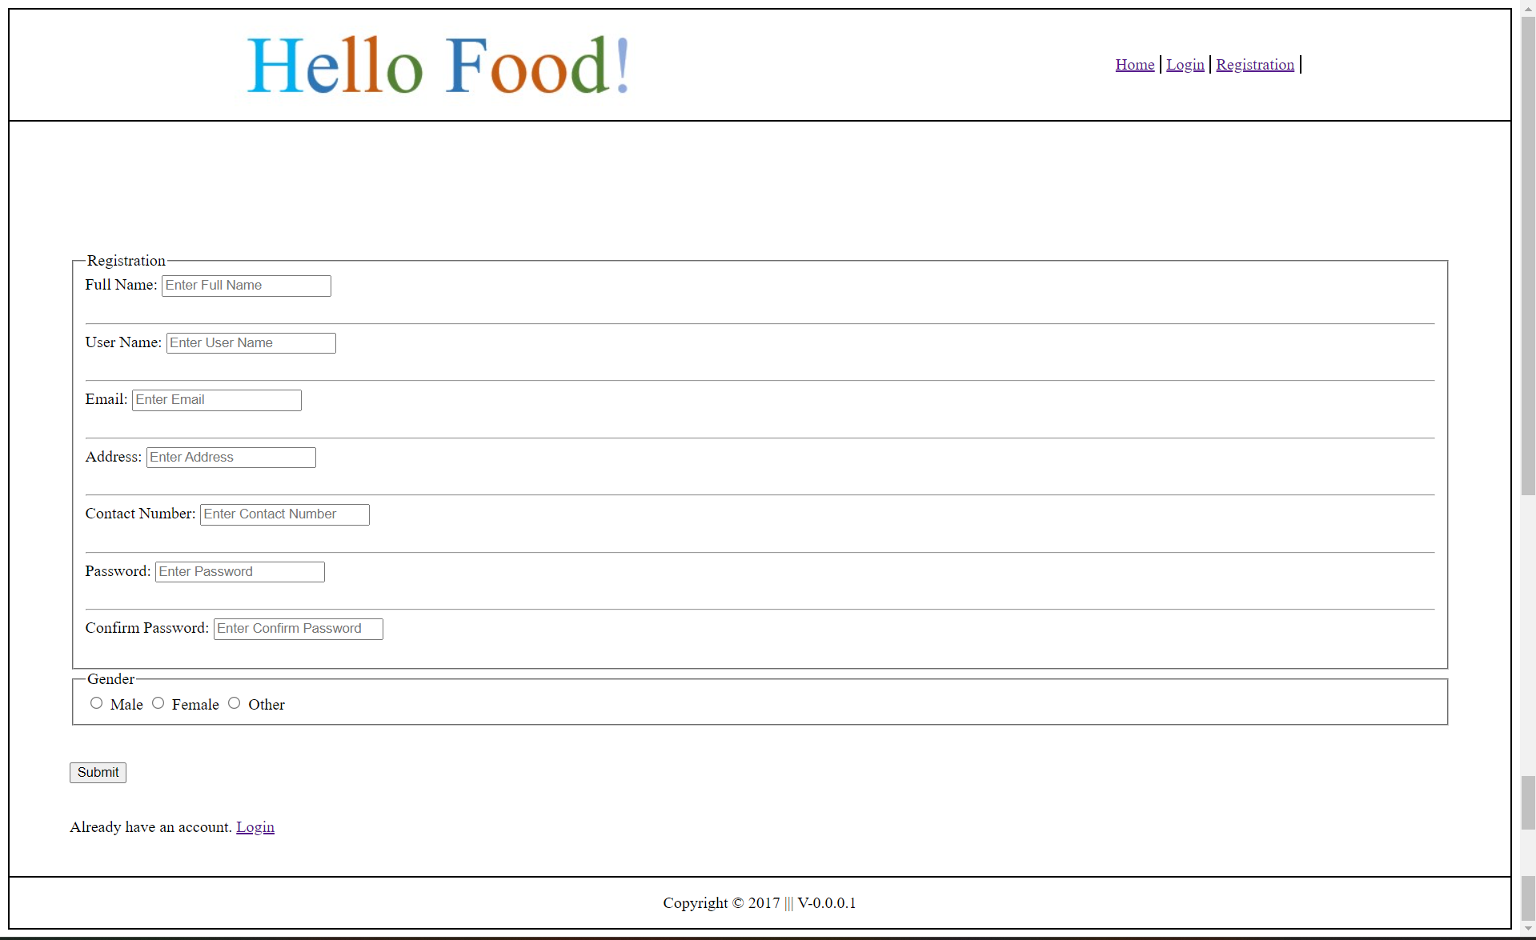

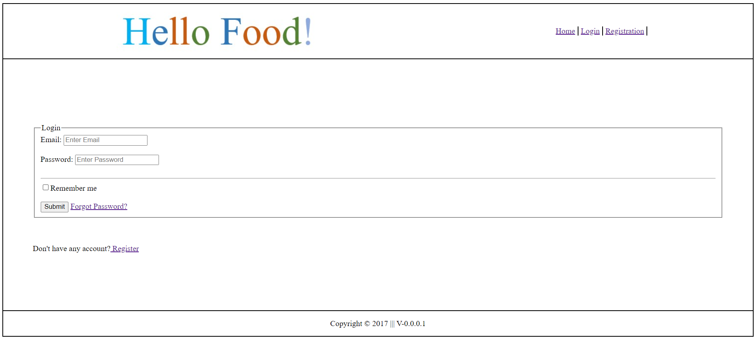

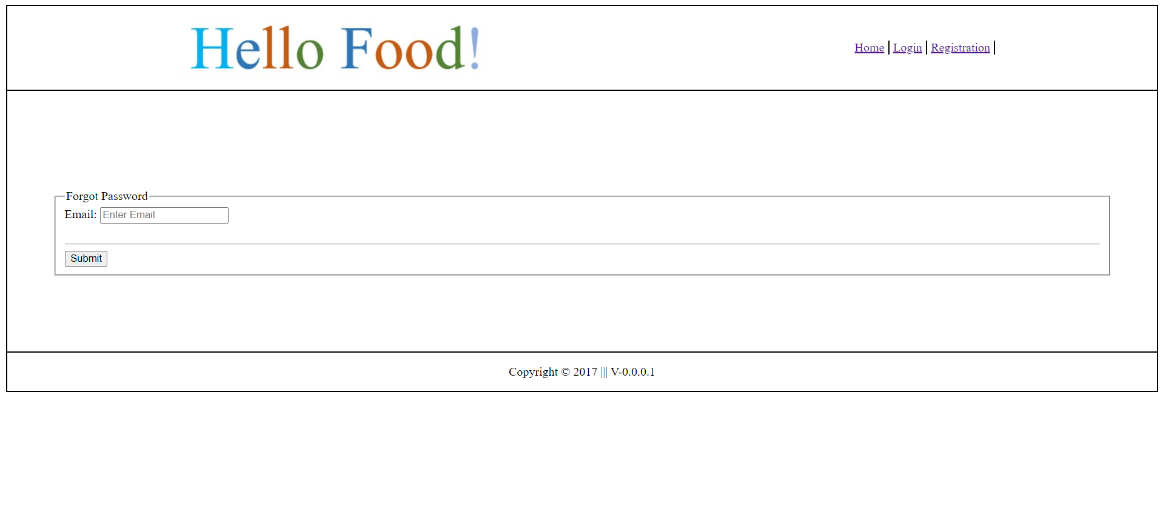

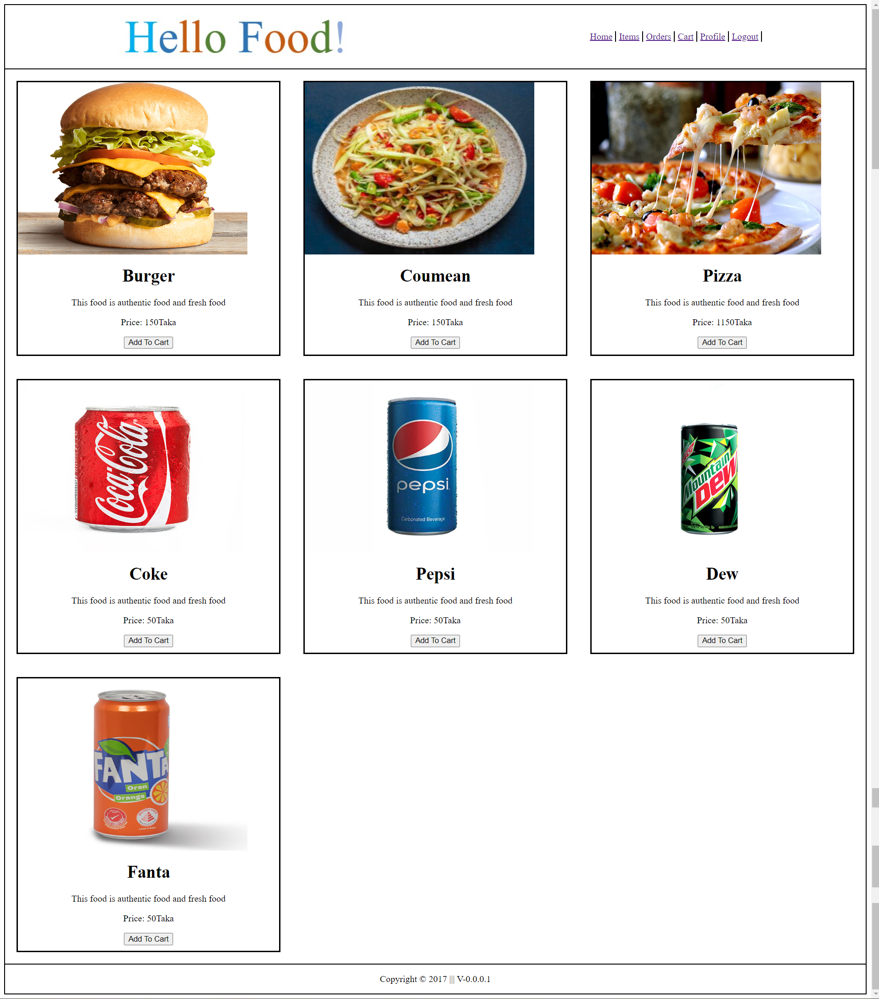

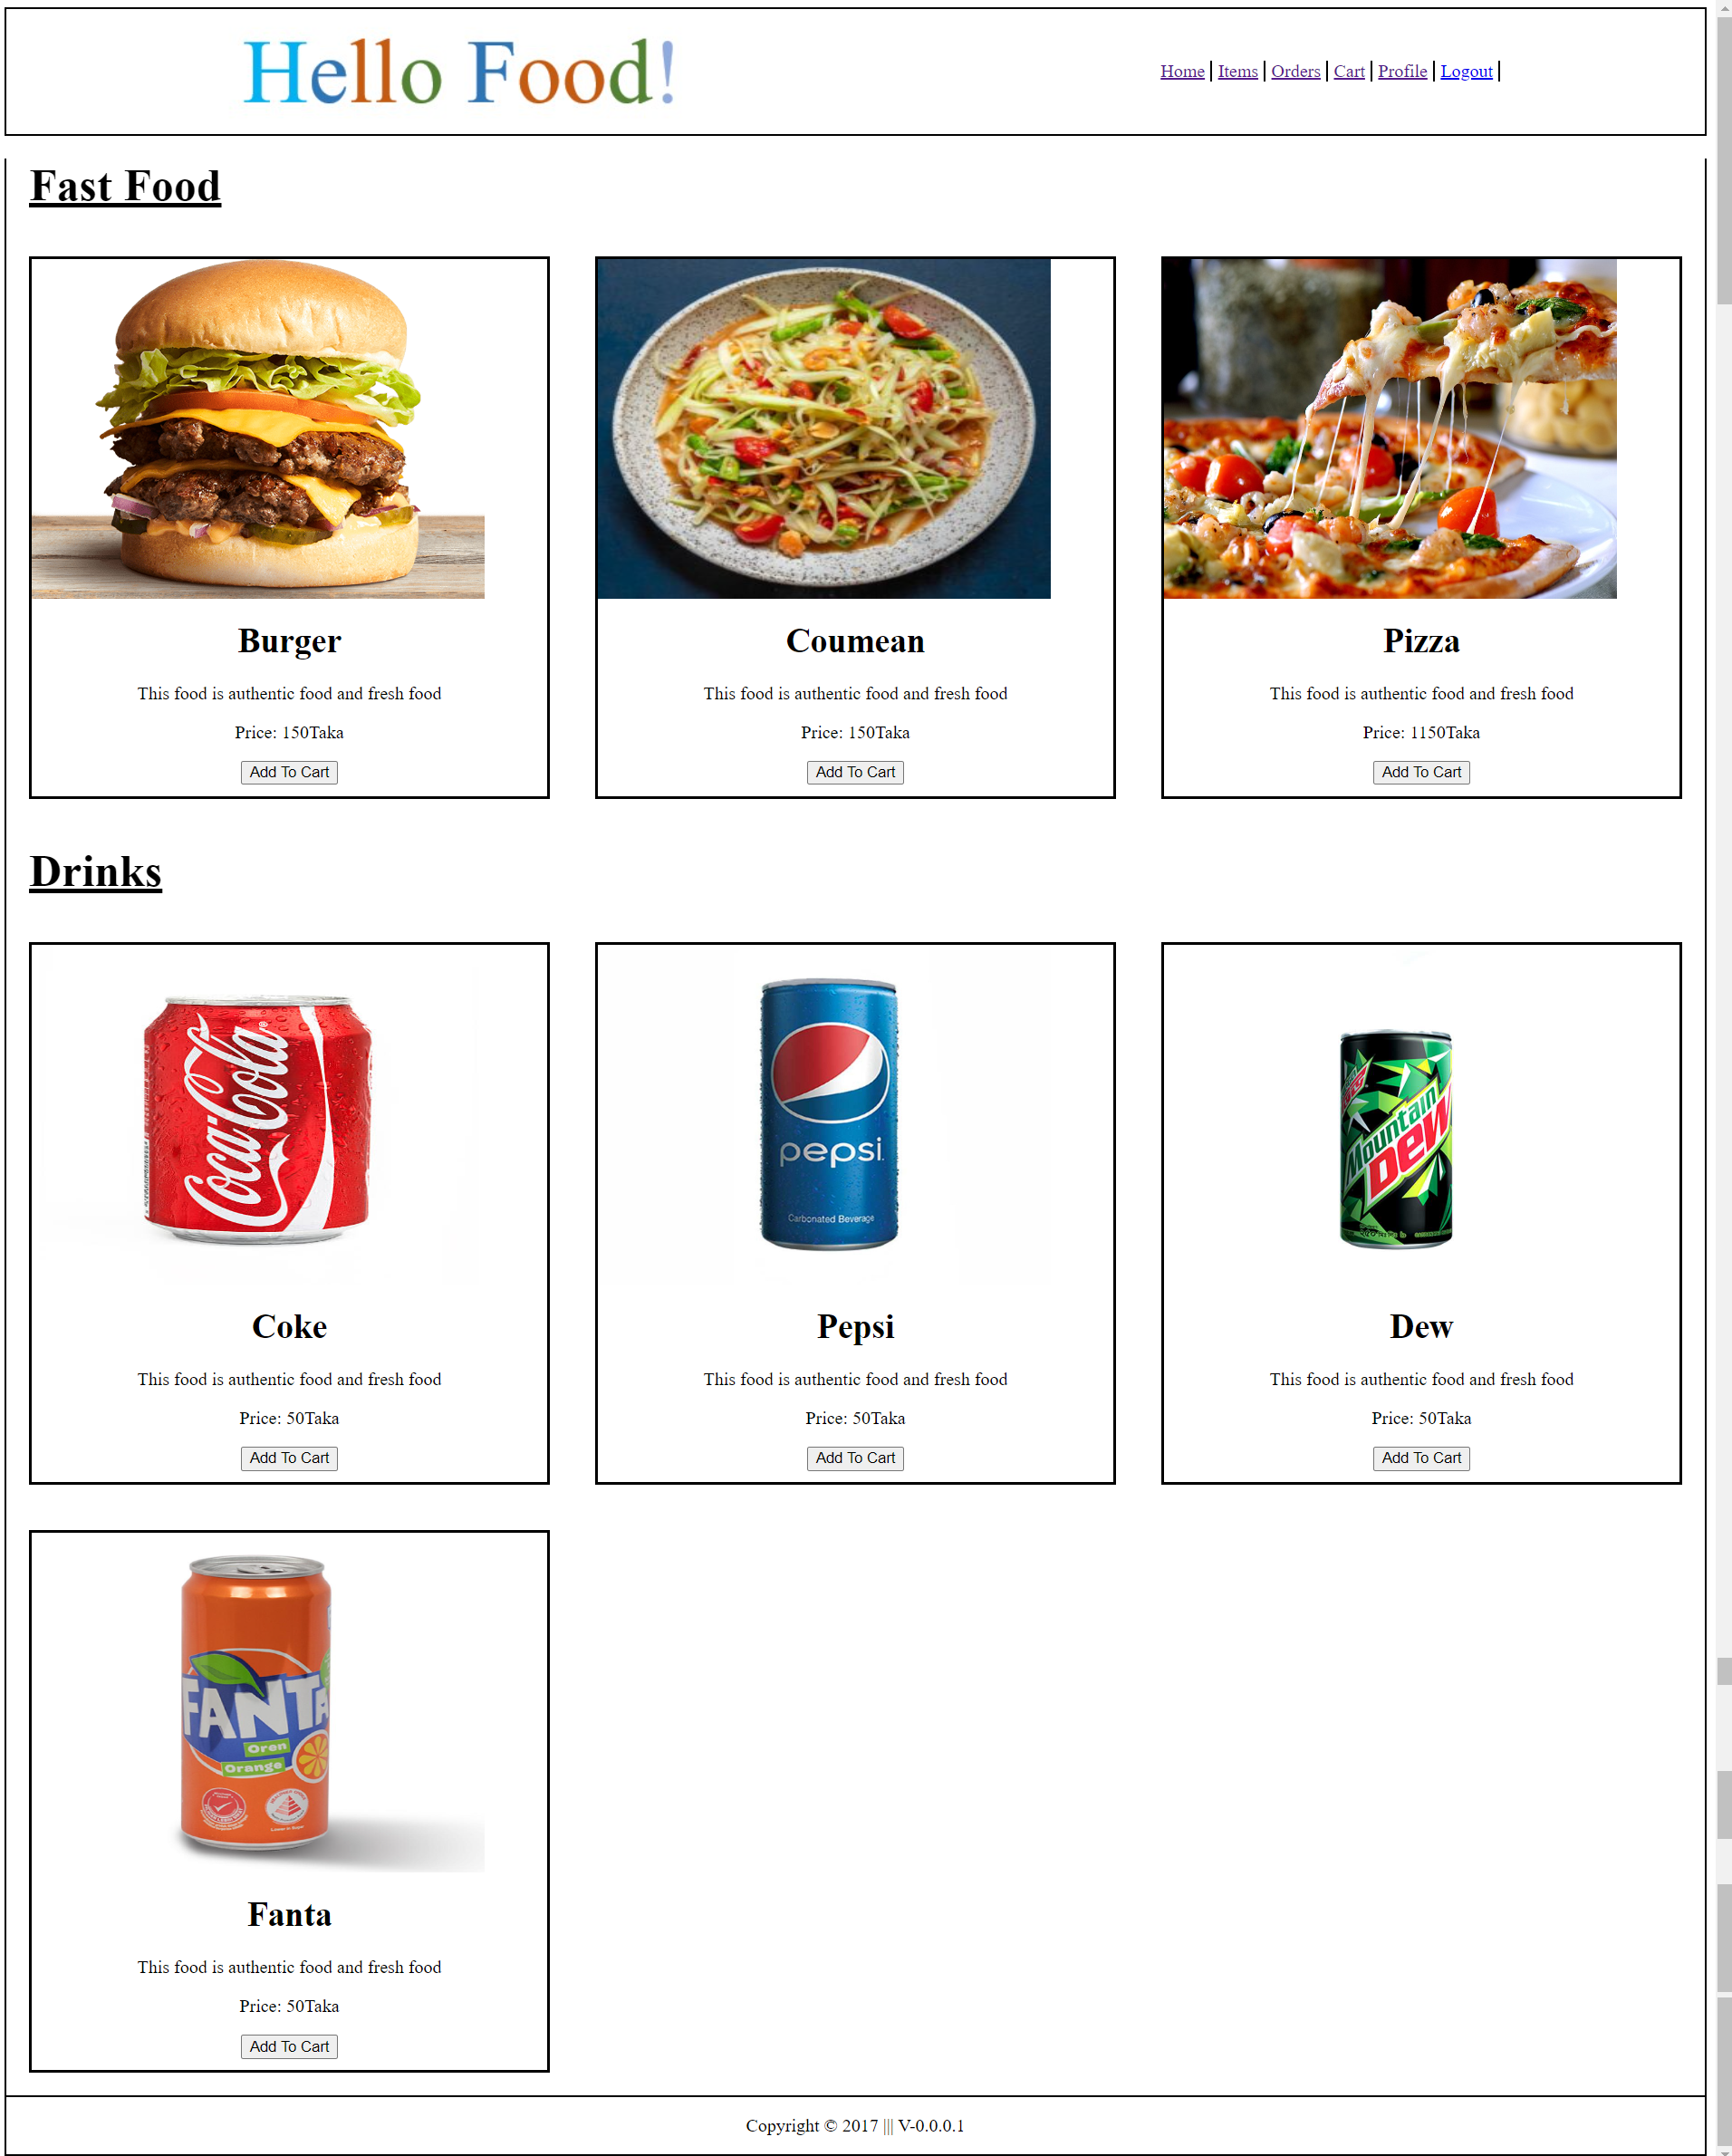

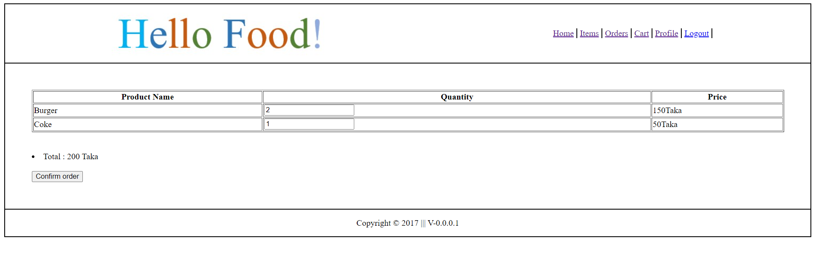

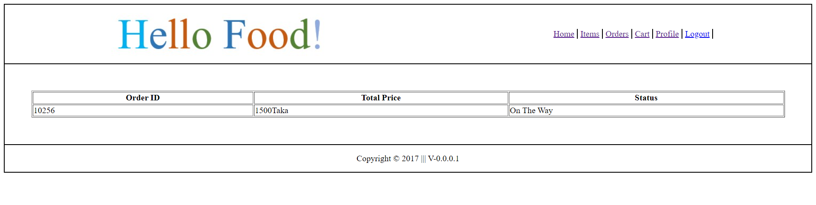

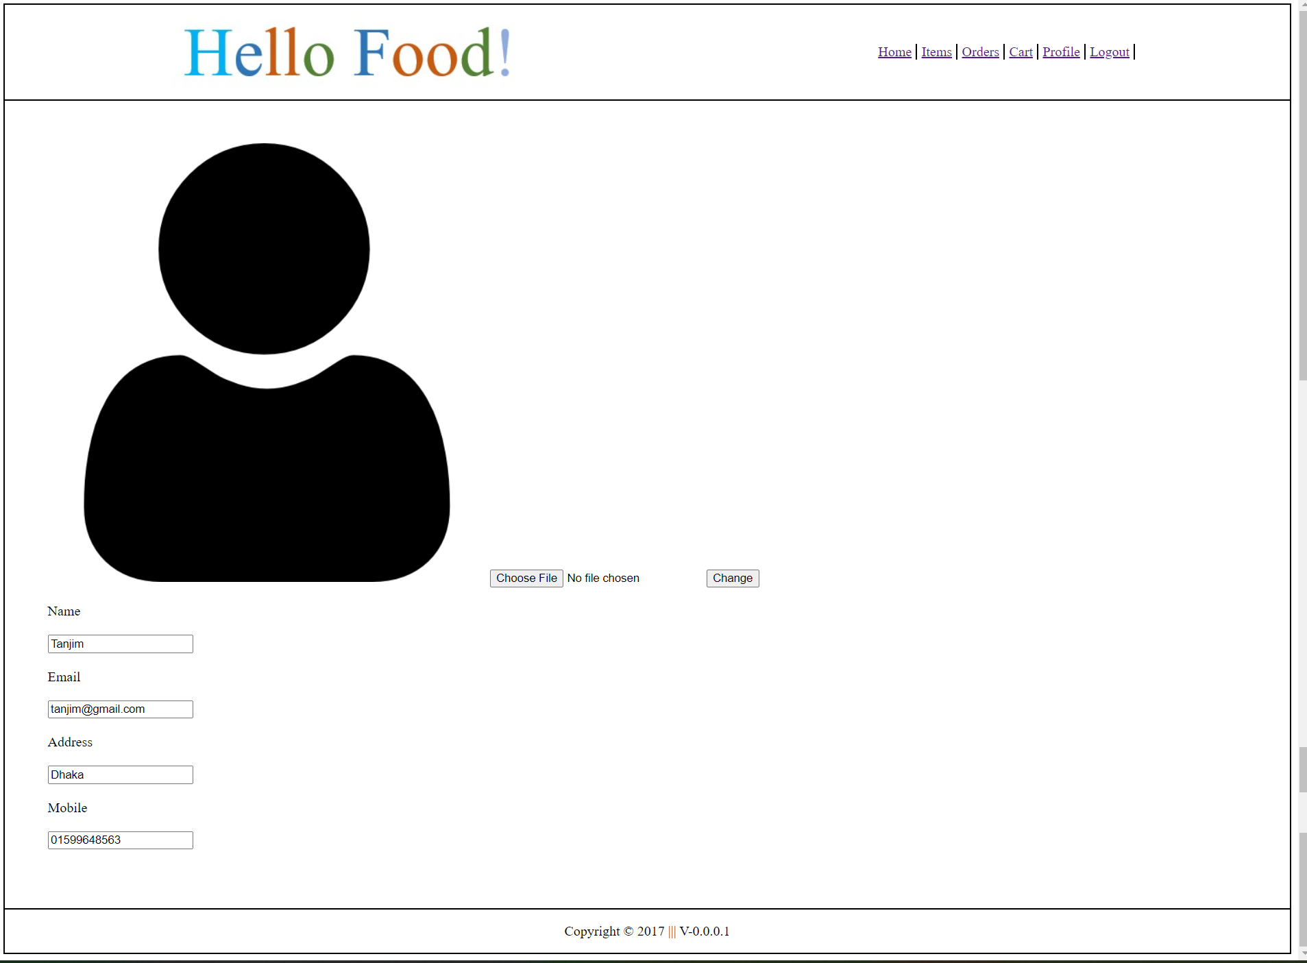

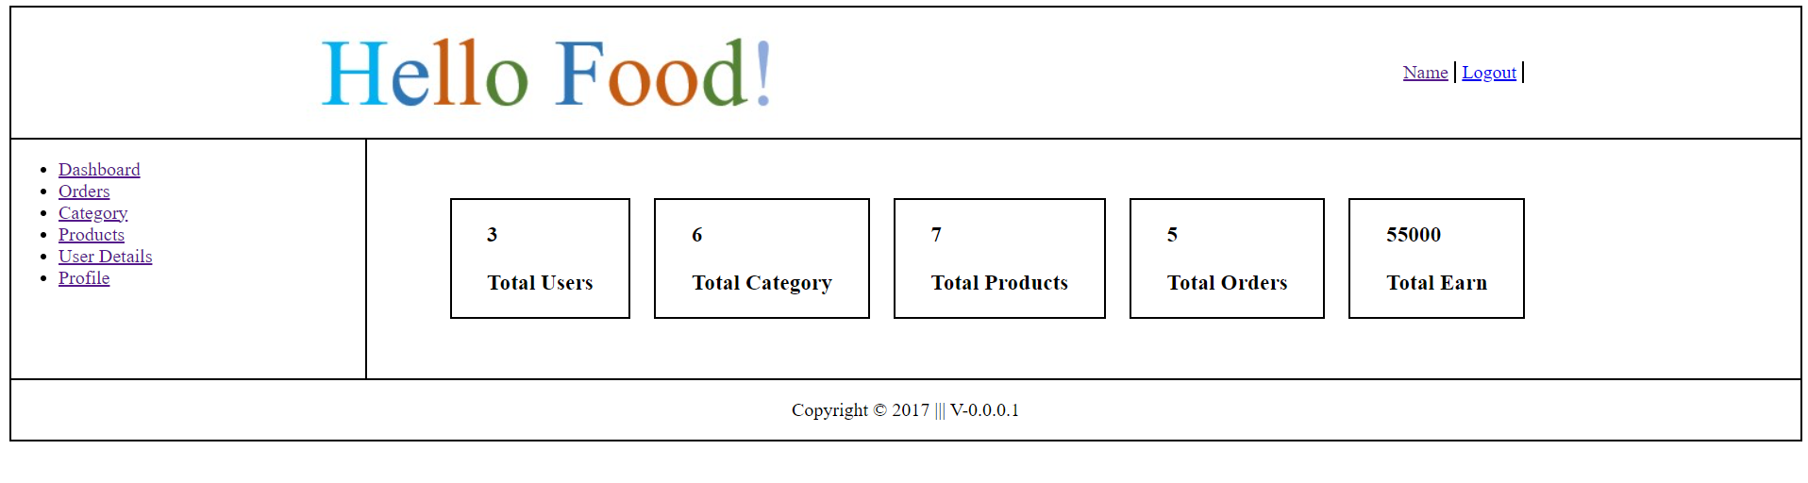

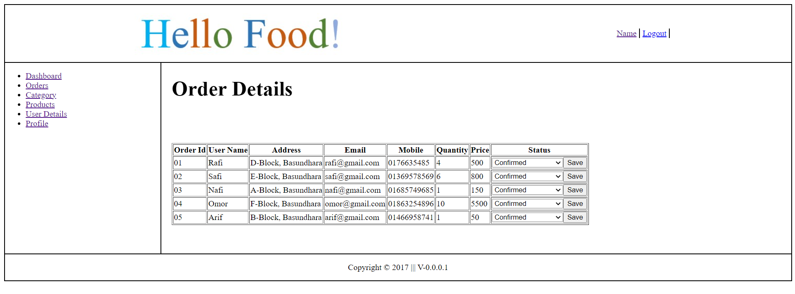

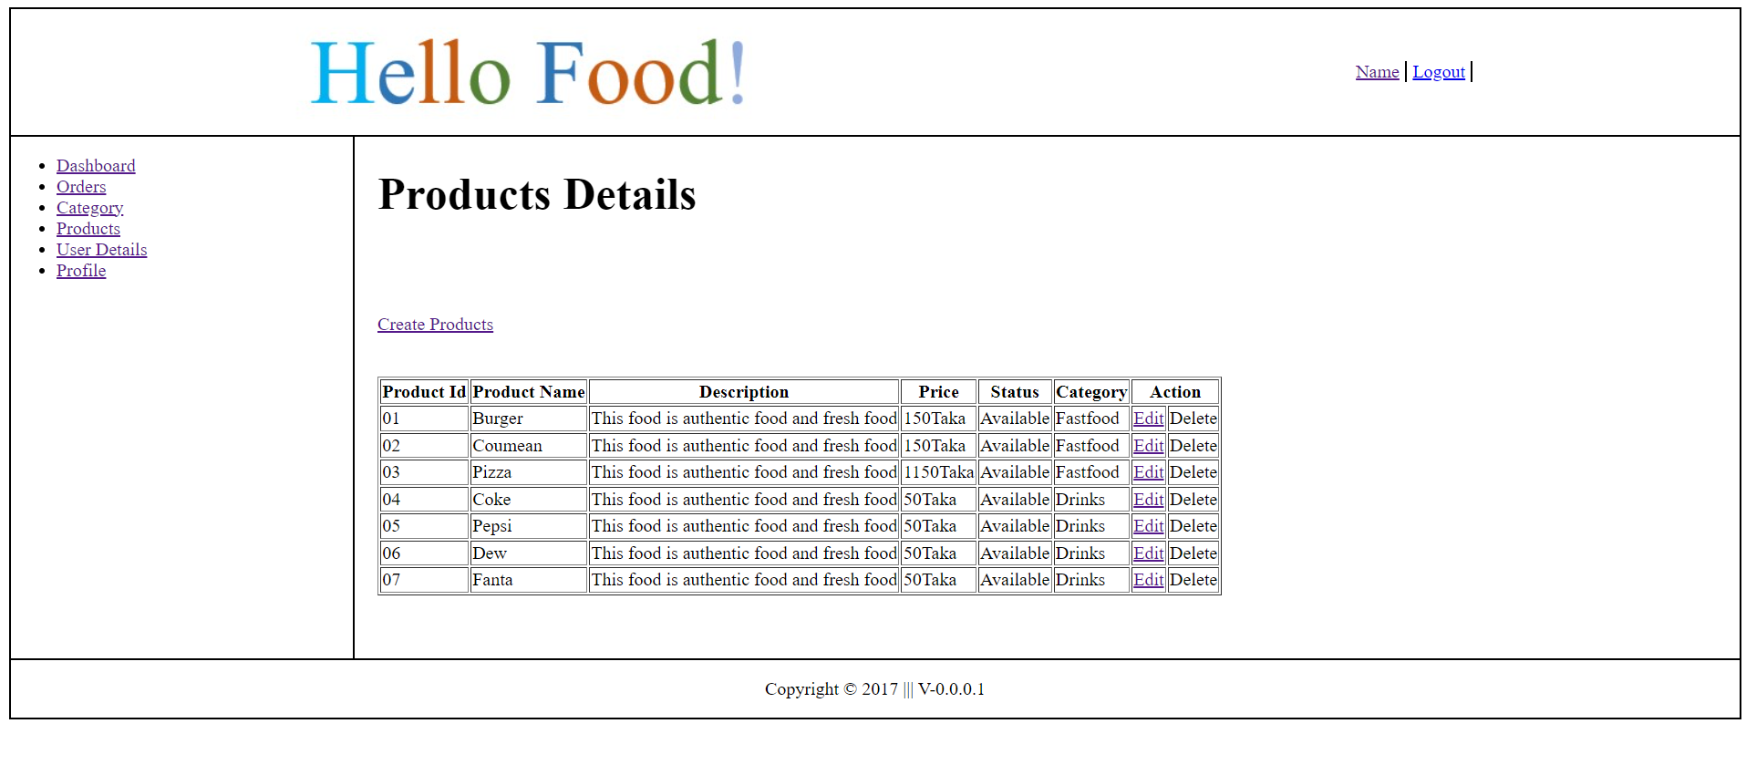

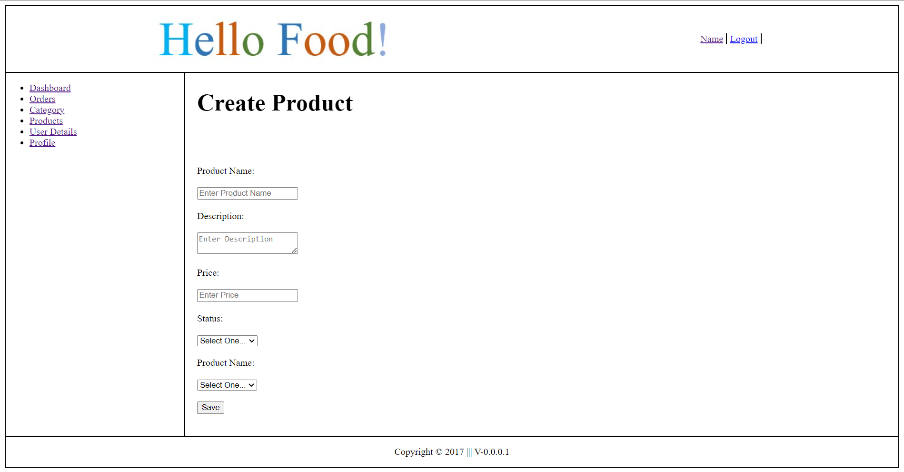

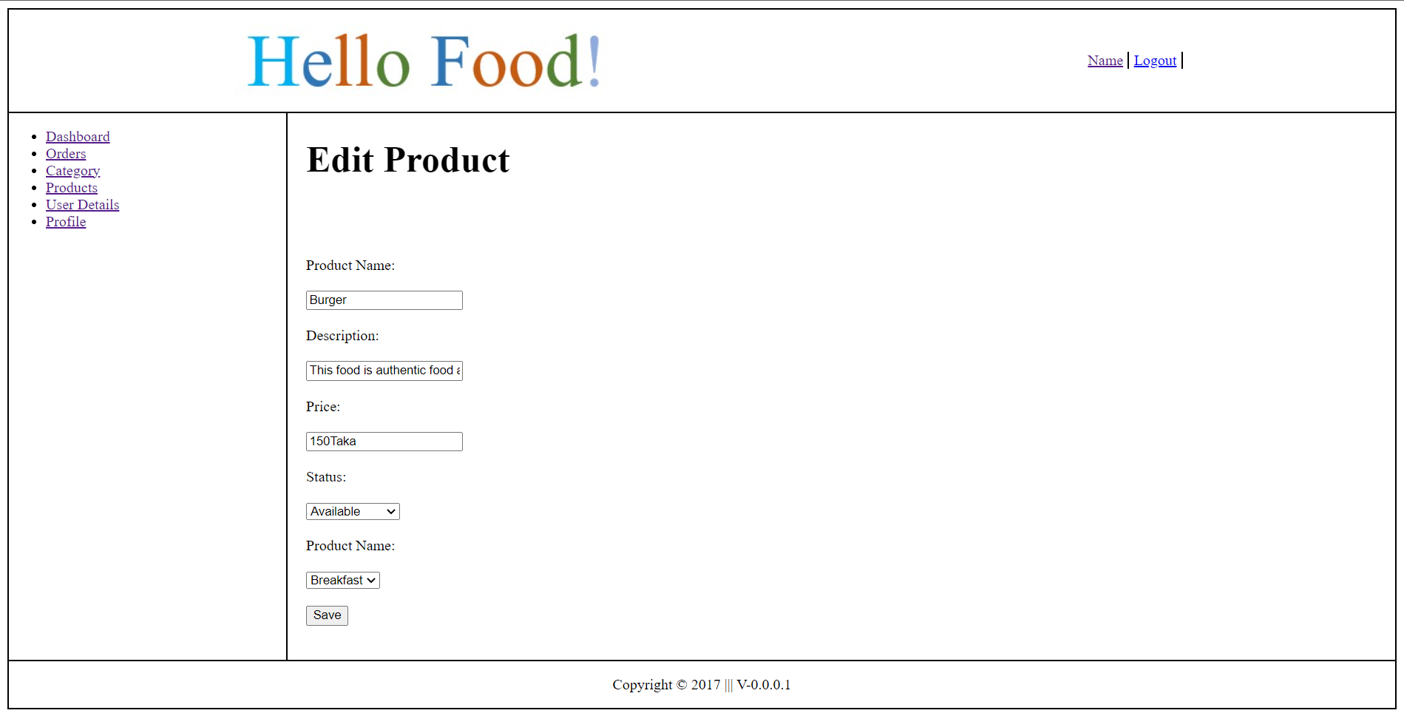

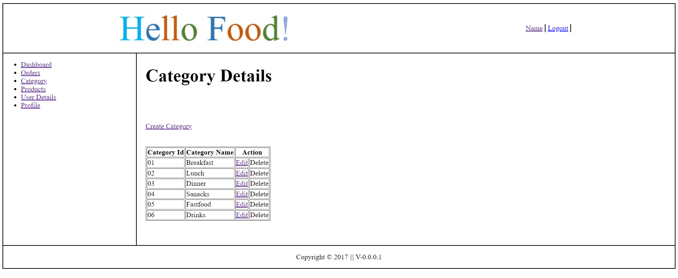

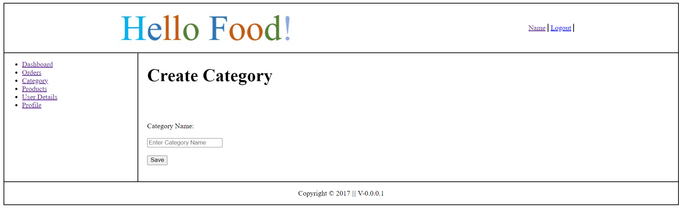

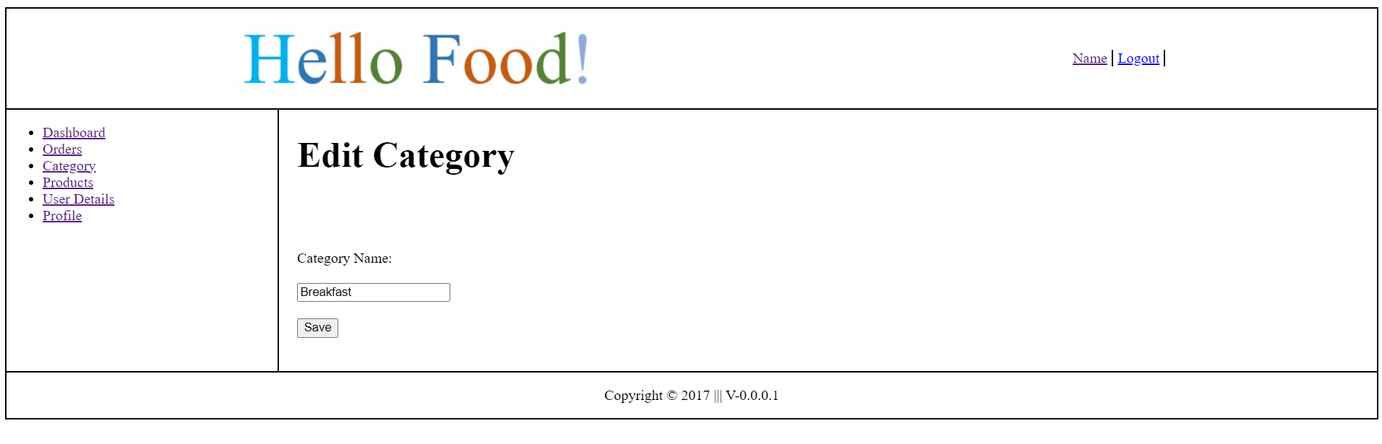

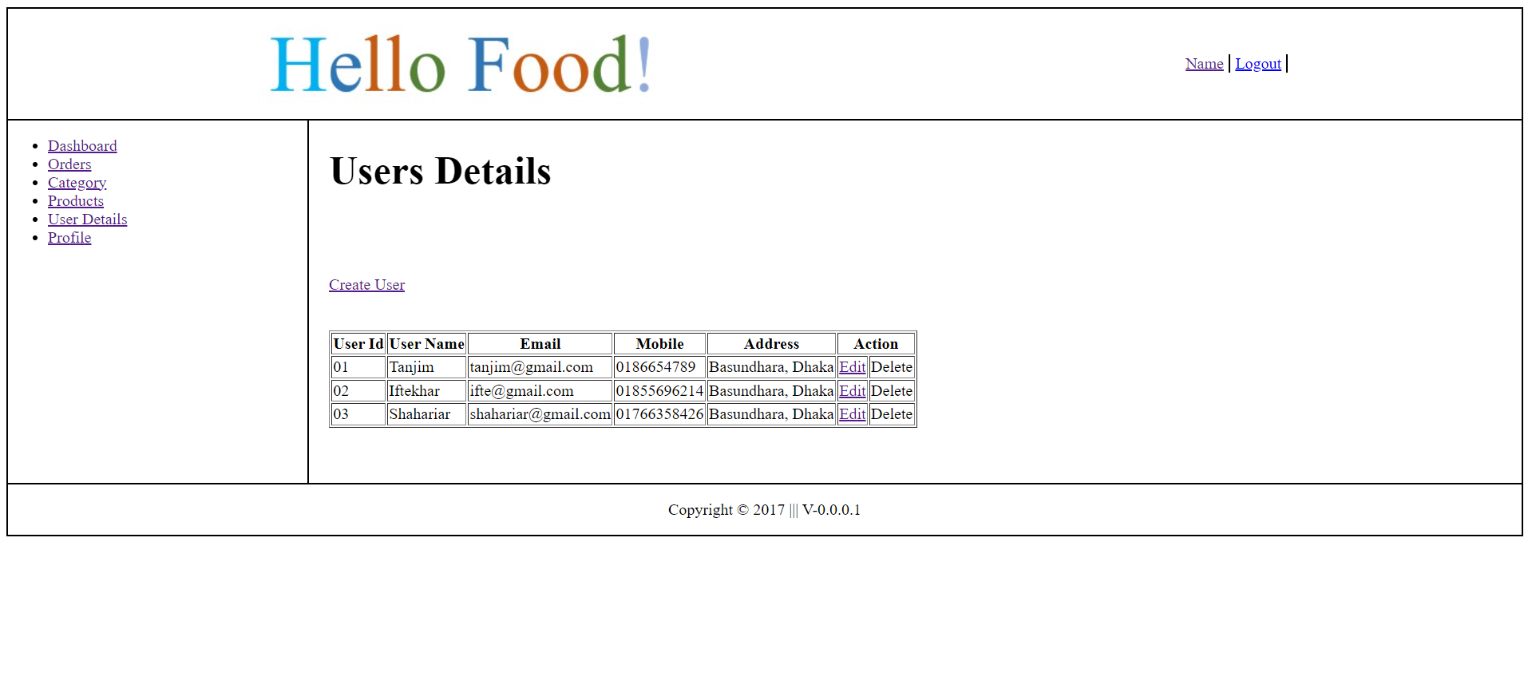

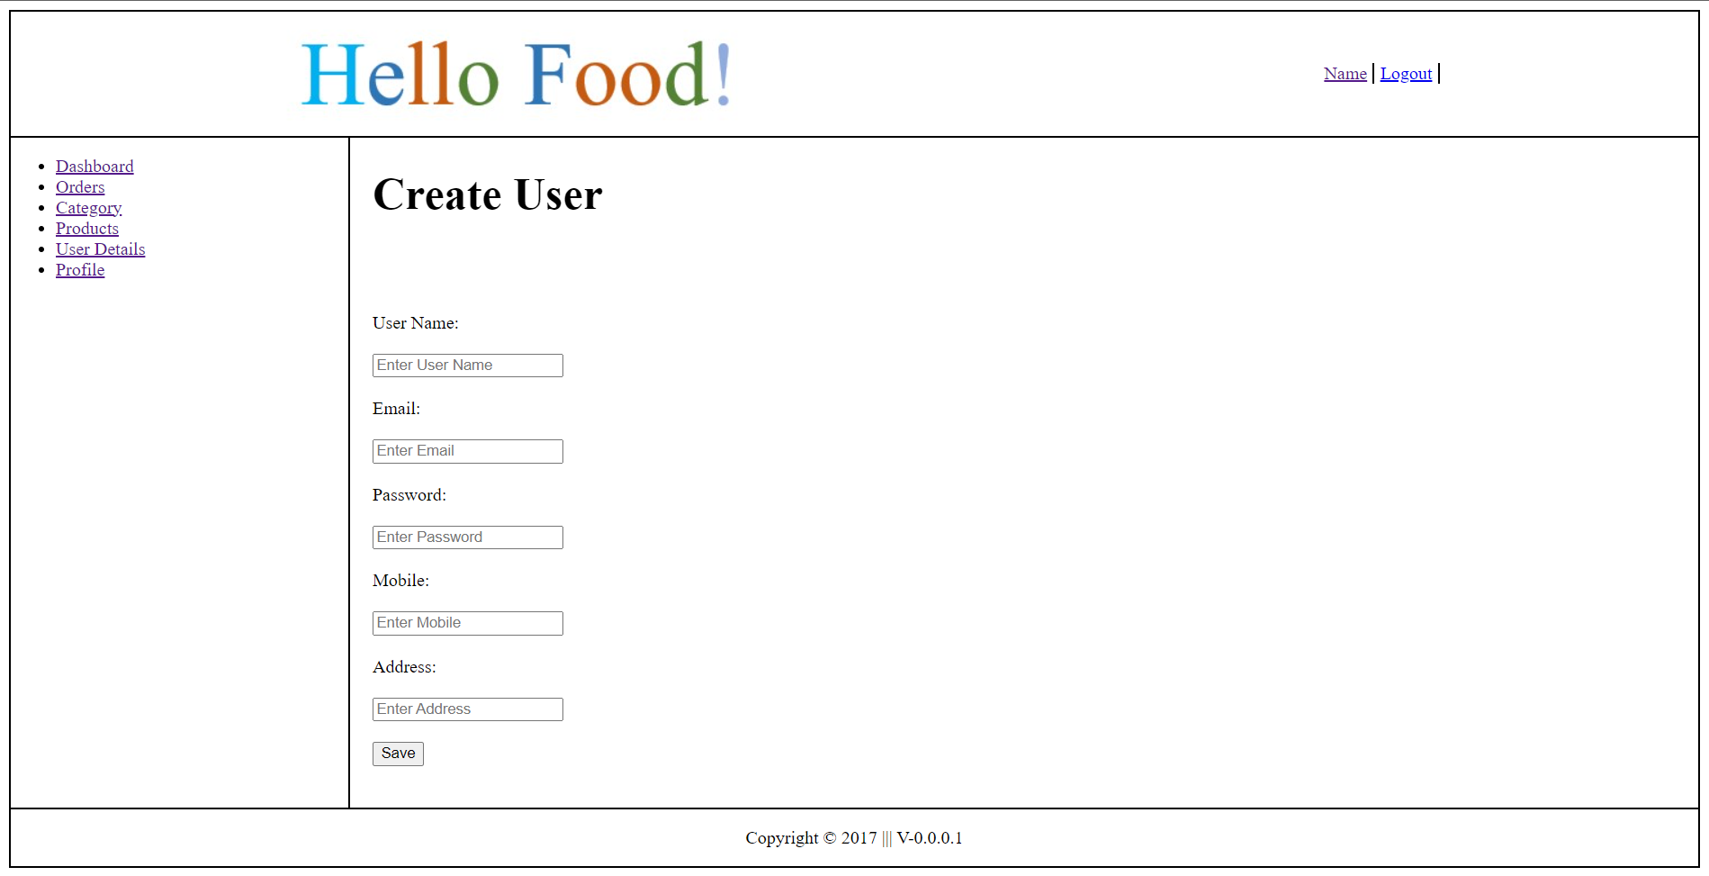

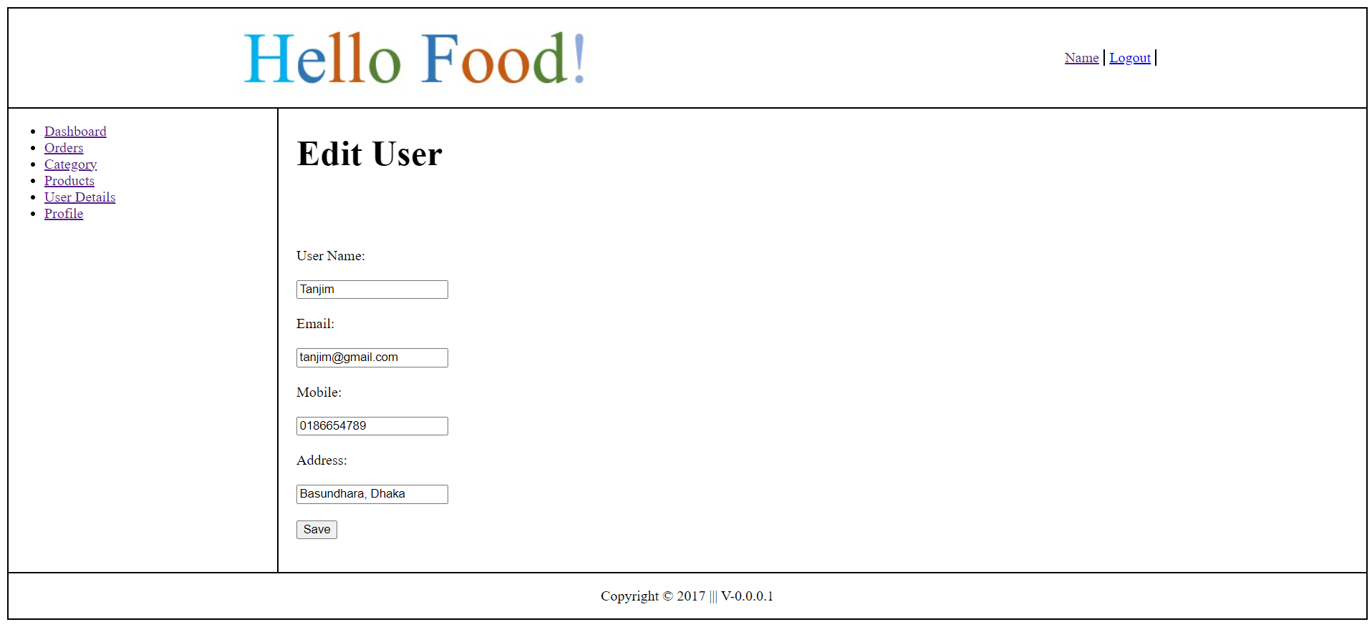

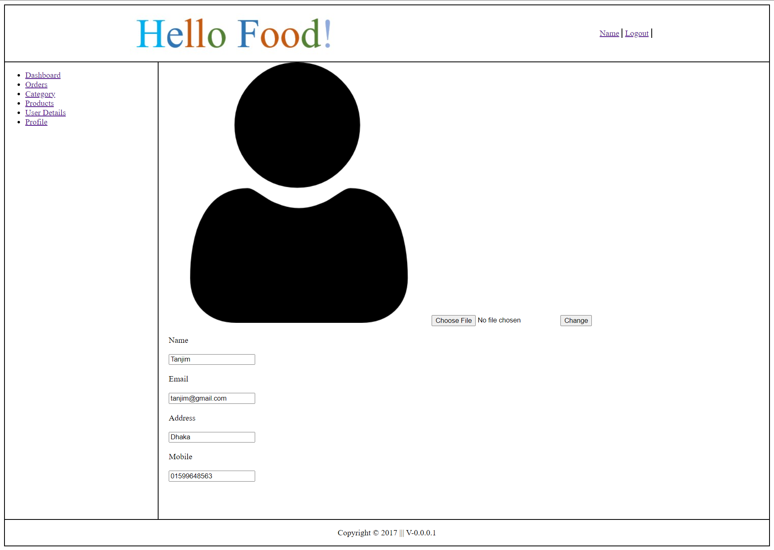

Impact of this Project:

A user can view all foods, choose one or more from the menu, and then place an order from their cart. The admin can then view the orders and modify the status after that. User is able to view the status of his or her food. Admin have the ability to add, edit, and delete users. can also delete a food, update the food's details, and add new foods.

Limitations and Possible Future Improvements:

We will soon assign a another user with the name employee. Here, the admin is functioning as an employee, but we want to add a different user, an employee, who can view orders, modify orders, and keep records of orders.

*[Note: Make sure that your report is maximum 10 pages (including cover page). Print (Colored) the report and submit it with spiral bind.]*

|  |  |  |  |  |  |
| --- | --- | --- | --- | --- | --- |
| CO1.1 and CO2.1 Evaluation: Project Report Evaluation | | | | | |
| Project Proposal  (5) | Background  Study  (5) | Requirement Analysis  (5) | Entity  Diagram  (5) | System Images  against the  Specification (5) | Total (25) |
|  |  |  |  |  |  |
|  | | | | | |